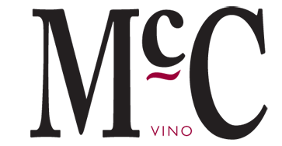
Qwwdq
Cabarnet Franc-Cabarnet Sauvignon
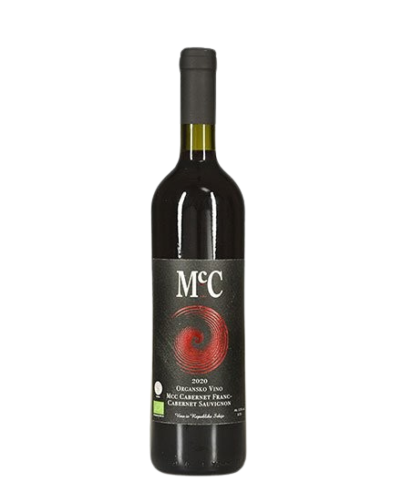
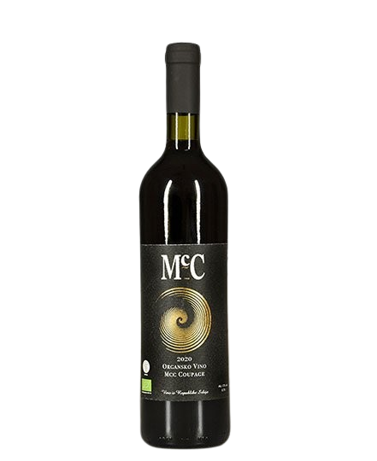

About the wine
- Dry red wine -
-

Grape variety:
- Cabarnet Sauvignon
- Cabarnet Franc
Origin: Erdevik, Fruška Gora
Serving temperature:15-17 ºC

A blend of two grape varieties, dominated by Cabernet Sauvignon at approximately 60%, with 40% Cabernet Franc.
Aged for 18 months in oak barrels and a minimum of 10 months in the bottle.
A blend of two wines with a pronounced fruity character (black berry fruit), complemented by notes of flowers and green pepper. Through the aging process, the wine has developed notes of vanilla, tobacco, and sweet oak.
This wine pairs beautifully with grilled dishes, steak, pork loin, turkey with sauerkraut, and traditional dishes prepared under the sač.
We use the Bordeaux technique of co-fermenting grape clusters. Cabernet Franc and Cabernet Sauvignon are fermented together. Since the varieties do not ripen at the same time, the goal is for the Cabernet Franc to be slightly overripe, while the Cabernet Sauvignon remains fresher and greener.
We produce an average of around 1,000 bottles of Cabernet Franc–Cabernet Sauvignon per year.
This wine is becoming increasingly popular in Serbia, and with its characteristics it proves that it is capable of competing at the highest international level.

Awards :

2024- Gold medal for the 2018 vintage at Wine Vision by Open Balkan.
2023- Gold medal for the 2018 vintage at Wine Vision by Open Balkan.
2022- Top 50 wines of Fruška Gora

